SPUN SEDIMENT FILTERS
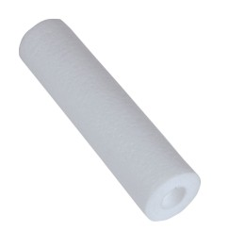

Water Purification Supplies cartridges are constructed with multi-layers depth filter cartridges and manufacture by meltblown process. The meltblown cartridges feature graded density construction, which captures particles throughout the entire cross section of the cartridge and reduces surface blinding, which can occur in string wound cartridges.

Water Purification Supplies cartridges combine quality and cost effectiveness to provide excellent filtration value.

Features & Benefits:
Certificated by NSF 42 standard
FDA Compliant V
ISO 9001 certified
Pure Polypropylene construction
Highly Price Competitive

Operation conditions:
Maximum operating temperature: 52 ℃
Maximum operating pressure @20 ℃: 3.2 kg/cm²
Recommended replaceable pressure drop: 1.5 kg/cm²

Applications of product:
Removal of Sediment from water in residential and light commercial applications

Product specifications:
Micron ratings: nominal 1, 5, 10, 20, and 50 microns
Materials of construction: 100% Polypropylene
Length: 9 7/8”, 10”, 20”, 30”, and 40”
Inside diameter: 1”
Outside diameter: 2.5” or 4.5”

